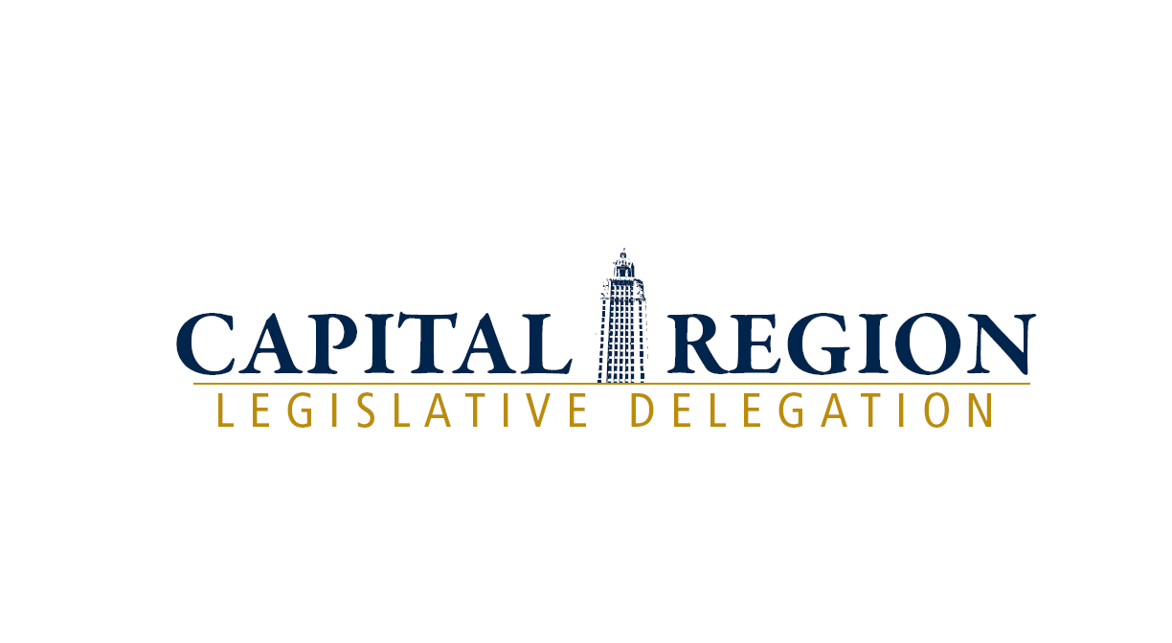

FOR IMMEDIATE RELEASE
Contact Information: Errin Flynn
Executive Director
225-235-0411
errinflynn@gmail.com

Capital Region Legislators Meet with Governor Jindal to discuss 2015 Legislative Agenda

BATON ROUGE, LA (April 13, 2015) – The Capital Region Legislative Delegation has been working over the past several months to determine its 2015 Legislative Agenda. The delegation held its annual meeting with Governor Jindal in March and requested his support of Capital Outlay projects that the Delegation believes have a significant impact on the state and region. The Delegation continues to be grateful to Governor Jindal and his administration for their continued support.

The Capital Region Legislative Delegation set forth the following transportation and economic development infrastructure projects as its top priorities to see funded during the 2015 Regular Session. These projects will stimulate continued economic growth in the region, improve highway safety and traffic congestion, and improve the overall quality of life for the citizens of not only the Capital Region but in many ways the entire state.

The Delegation divided proposed projects into two categories – Previously Unfunded Projects and Newly Proposed projects for 2015. Previously Unfunded Projects were included in the Delegation’s top priority list from 2014 but were not funded. These, as well as all prior year projects continue to be important to each of the Members of the Capital Region and will continue to be supported through the 2015 Legislative Session.

Previously Unfunded Projects – Ranked in order of priority
- Overlay Head of Island LA 16 to Port Vincent - $5 Million needed to overlay this deteriorated roadway due to growing population in the area. This is an 8.9-mile segment of roadway.
- I-10 & Hwy 74 Interchange - $1 Million - Project consists of a new interchange at I-10 and LA 74 near Dutchtown in Ascension Parish. Currently there is no funding.
- Go Program - $2.25 Million - Proposed improvements will consist of expanding the existing two lane roadway into a four lane divided roadway including intersection improvements at all major intersections, consisting of roundabouts or dedicated turn lanes. In order to accommodate safe, access to business/facilities located along the corridor, u-turns will be strategically located along the route. Capacity and safety will be the primary consideration for all improvements.

2015 New Projects – Ranked in order of priority
- Replace LA 16 Bridge over Amite River – $2million – This bridge was built in the late 1940's as a hot rivet drawbridge. The bridge no longer meets the industry standards in width for 18-wheelers. If this main artery were to stop, trucks transporting goods to plants would have to go 40 to 50 miles out of the way. This would increase the cost for transporting and cause the trucks to travel on a highway with higher traffic volume.
- City of Zachary – $1.92 million - Water Distribution System Improvement
- Livingston/Ascension Wildlife & Fisheries Outpost on the Diversion – $200,000 - Construction of a small facility to use for waterway law enforcement housing and staged response.
- False River Ecosystem Restoration Project – This is an existing project that is requesting $500,000 in new money.
- Capital Area YMCA-Long Farm – $300,000 - YMCA is a cause-driven organization that enhances the quality of life physically and mentally for the citizens of the community it serves. This area of the Capital region is rapidly growing and would be well served by a YMCA facility to offer community services including a Council on Aging. Land estimate of 1.3 million is being donated along with Capital Campaign of 2 million.
- Town of Livingston Water Tower/Well – $1 million - Construction of a new elevated water tower and water supply well and will serve the area near the I-12 and Highway 63 intersection, both north and south of I-12.
- Overlay of LA 22 from Head of Island to Chinquapin Bridge – $2.8 million - LA 22 is a major 4.1-mile highway that supports industry and tourism in Livingston, Ascension and St. James Parishes. This highway is in deplorable condition with a bad base and no shoulder. Repair of this road is needed to keep economic development moving forward in the river region.
- Livonia Sewer extension – $900,000 - Expansion would include service to 20 homes and businesses. Removes septic discharge from roadside ditches, and provides for generators for sewer lift stations.
- Springfield/Killan Police Joint Facility – $500,000 - Construction of a joint facility that will house the fire and police service for the communities of Killian and Springfield. The facility will be used as a staging, distribution area and safe haven during storms.
- Village of Norwood – $106,767 - Fire Department Roof
- Town of St. Francisville – $1.6 million - Mississippi River Access Road

There are still many ongoing projects impacting all areas of the region that the Capital Region Legislators have worked on securing funding for over the past 8 years. All of these projects were also discussed in the Delegation’s meeting with the Governor as they have continuation funding needs. Some of them are highlighted below:

- Improvements on LA 3038 (Ascension Parish) – $1M-$2.5M (Rough Estimate) – LA 3038 overlay and turn lane project – Working with the City of Gonzales to develop plans for a project that will involve resurfacing and base repair to LA 3038 from Airline Highway to just west of North Bryan Avenue. A left turn lane will be added to LA 3038 westbound onto Irma Boulevard and a right turn lane will be added from LA 3038 eastbound onto Irma Boulevard. It is difficult to give a hard timeline because the City of Gonzales is responsible for developing the plans and ROW maps. ROW will need to be acquired to construct the turn lanes. It is estimated that the project could be let to construction in 1-2 years. It has $800,000 in Priority 1 CLOL.
- I-12 Widening to Walker/Satsuma (EBR, Livingston) – The current funding includes $48,000,000 in Priority 1 CLOC GOBONDs and sold GOBONDs. Two of the projects are complete and the last project was let 10/9/13.
- Hooper Road Widening and Extension (EBR) – Project currently has $2.7M in Priority 1 CLOC. DOTD requested $4.2M in new Priority 2 CLOC in the 2016 Regular Session in order to advance to the preconstruction engineering, stage
- LA 1/LA 415 Connector (WBR) – Project is currently at 95% preliminary plans and is on hold until a PPP funding source is obtained. It has $570k in Priority 1 CLOC and $6.0M in Priority 5 NCLOC.
- BUMP (EBR, WBR) – Current funding consists of $1.0M in Priority 2 CLOC GOBONDS and $2.5M in Priority 5 NCLOC. This year $2.5 million is being requested to move from Priority 5 to Priority 1.
- LA 70 to LA 22 to Sunshine Bridge (Ascension) – Project consists of widening LA 70/LA 22 from 2 to 4 travel lanes between I-10 and Sunshine Bridge in Ascension and St. James Parishes. Project currently has $1.0M in Priority 2 GOBONDS and $3.0M in Priority 5 NCLOC.
- West Side Expressway (Iberville, WBR, WBR) – Requesting $1,650,000 in Priority 5 NCLOC GOBONDS be converted to Priority 1 CLOC in SFY 15-16 to complete the environmental assessment.

###
About the CRLD: The CRLD is made up of the 30 State Senators and Representatives who represent the nine parish Capital Region and works to serve as the central voice of constituents who live, work and play in the region. Members of the Delegation are educated throughout the year on issues that impact the region. Then, they work to identify and advance initiatives that will improve the quality of life for our constituents in the short term while at the same time identify long-term strategies to prioritize and advance issues that will improve the quality of life for all Louisianans.

